An Ant Colony Optimization Implementation for Survivable Routing and Wavelength Assignment in Optical Networks
P.Rajesh _{M-Tech student,} M.Ranga swamy_{,M-Tech student,} C.Azhar Ahamed _{M-Tech student}
Dept of E.C.E Dept of E.C.E Dept of E.C.E
JNTUA College of engineering pulivendula. JNTUA College of engineering pulivendula. JNTUA College of engineering pulivendula.
E-mail:raj06453@gmail.com E-mail:-ranga3817@gmail.com E-mail:-azharahamed8@gmail.com

Abstract:-
In this paper, we investigate a new ant-based agent algorithm for providing survivable routing in WDM network. The major problem in survivable routing wdm network is routing wavelength and assignment (RWA) problem, It sets up light path by routing and assigning a wavelength to each connection such that no light path use the same wavelength on same link .Our study aims to develop an Ant based light path setup for survivable routing WDM by use of Ant Colony Optimization (ACO) which supports to run continuously thus it can provide dynamic path. By adopting a new routing table structure and keeping a number of ants in the network to cooperatively explore the network states and continuously update the routing tables, our new ant algorithm can efficiently support the ants’ foraging tasks of route selection and wavelength assignment in WDM networks. Each path in the network is assigned by feasibility value. This feasibility value is calculated by considering the metrics such as bandwidth availability, path length and number of free wavelengths. When an ant is launched in the network by its node, it moves towards random destination to gather information such as bandwidth availability, path length and free wavelengths in that path. After gathering the information it updates pheromone table, which is feasibility value of corresponding path. On completing the updating of pheromone table, the ant updates load of that particular path in the load table. The value of path load is dynamically updated by the ant in the load table.
Keywords:- Light path setup, protecting and restoration, routing assignment.,
1. Introduction
All optical networks that adopt wavelength-division-multiplexing (WDM) technology have a huge bandwidth capacity, and they show promise as the backbone of the next generation Internet. In all optical networks, data are routed in optical channels called light paths. [1]The Routing and Wavelength Assignment (RWA) problem is how to determine both a route and wavelengths for a connection request. Without wavelength conversion capability, a light path must use the same wavelength on all the links along its route, which is referred to as the wavelength continuity constraint.The RWA problem is usually classified as the static RWA problem and the dynamic RWA problem. In the static RWA problem, the
connection requests are given in advance, and the problem becomes how to establish light paths for all these requests so that the total number of wavelengths is minimized. Static RWA has been proved to be an NP-complete problem [2]. In the dynamic RWA problem, the traffic is dynamic with connection requests arriving randomly, making it more difficult. In a wavelength-routed network, a connection between a source node and a destination node is called a lightpath. A lightpath is an optical channel that may span multiple fiber links to provide an all-optical connection between two nodes.In the absence of wavelength converters, a lightpath would occupy the same wavelength on all fiber links that it traverses.Two light paths on a fiber link must be on different wavelength channels to prevent the interference of the optical signals.The next section discusses the Previous Research on RWA Algorithms. Then we discuss the significance of the problem and formally define our problem.
2. Previous Research:
2.1 Routing in WDM
WDM technology has enabled wavelength routing, which provides the high-speed bandwidth transparency than electronics could provide. [3] In a wavelength-routed network, a connection between a source node and a destination node is called a light path. A light path is an optical channel that may span multiple fiber links to provide an all-optical connection between two nodes. [4] There are two main branches of research in RWA algorithms: static RWA and dynamic RWA. Both approaches first consider the routing aspect and then choose a wavelength based upon the route selected. Let us take a brief review of both approaches.
2.1.1 Static Routing:
In the static routing approach, all connection requests are known in advance. In other words, both the routes and wavelength assignment can be calculated off-line. The input to the problem is a network topology and a set of connection requests. These approaches typically use one of two optimization approaches: minimize the number of wavelengths necessary to meet the traffic demands or maximize the number of connections that can be established (minimize the blocking probability). [5] The typical method of solving a static scenario optimally is through an Integer Linear Program (ILP). This approach can be used for smaller networks. A formulation for RWA is given in [5]. An improved formulation that uses fewer variables and thus runs more quickly is given in [6]. However, this approach is not feasible for medium and large networks due to the complexity of solving ILPs. For larger network simulations, approximation algorithms are used. Some typical heuristics are a Partial branch-and-bound algorithm [7] and a relaxation of the integer constraints [8]. Another approach is to randomize the routing and focus on the wavelength assignment [9]. These solutions tend to be good enough, but are usually far from optimal. Another approach for static RWA is to use a graph theoretic approach. Both the multi-commodity flow problem and graph coloring problem can be translated into RWA problems [10]. In [11] such an approach was used to show approximation bounds for various types of graphs (directed trees, single source multi-commodity and strongly connected graphs). Most of the current research in static routing is studying graph theoretic approaches; the ILP approach is well-studied.
2.1.2 Dynamic Routing
In the dynamic routing approach, the connection requests are not known in advance. In other words, routes and wavelength assignment are calculated on the fly. There are three main categories of dynamic routing: fixed routing, fixed-alternate routing, and adaptive routing.
- Fixed Routing:
The most basic approach is to use the same fixed route for all source-definition pairs.These routes are typically generated using either Dijkstra’s algorithm or the Bellman-Ford algorithm. The advantage of this approach is simplicity. The main disadvantages are that this can lead to higher blocking probabilities as some resources are used and low fault tolerance if a link is unavailable.
- Fixed Alternate Routing:
This approach is an extension of Fixed Routing. A list of routes is stored for all source-destination pairs. One well known algorithm for calculating the k disjoint paths is given in [12]. To meet a connection request, the source node attempts to establish the connection based upon the list of routes, in sequence. This approach has been shown to be a significant improvement over Fixed Routing. [13]
- Adaptive Routing:
In this approach, the routes are chosen dynamically, based upon the current network state. A list of routes is still stored for all pairs and the goal is to choose the route that is the least congested. The level of congestion is based upon the level number of wavelengths currently in use. A disadvantage is the computational complexity and increased network overhead; however this approach has been shown to perform much better than fixed9alternate routing.

3. Issues of survivable routing in WDM
Achieving survivable routing in WDM is a challenging task. It involves more issues while designing survivable routing mechanism in WDM. Some of the issues are described below,
- In providing survivable routing the major issue in WDM is routing and wavelength assignment (RWA) problem. It sets up light paths by routing and assigning a wavelength to each connection such that no two light paths use the same wavelength on the same link [14]
- The routing of the light paths on the physical topology can significantly affect the amount of capacity required for network survivability.[15]
- Since with WDM each physical fiber link can support many lightpaths, once the lightpaths are routed on the physical topology, it is possible that two or more lightpaths would share the same physical link. Hence, the failure of a single physical link, can lead to the failure of multiple links in the logical topology. [16]
4. Survivable Routing in WDM
Survivability of a network refers to the network’s capability to provide continuous service in the presence of failure. [17] Survivability is becoming an important issue in optical networks due to the huge bandwidth offered by optical technology. Survivable routing in Wavelength Division Multiplexing (WDM) networks focuses on designing light path routing strategies to improve survivability. The primary goal is to route the light paths that constitute the logical topology over the fiber network so that fiber failures will not disconnect the logical topology. [18]
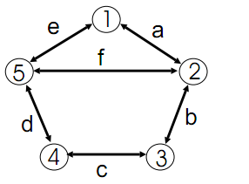
Fig1: logical topology
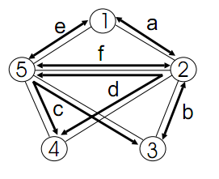
Fig1.1: survivable routing
5. Problem Definition
Our approach is to use Ant Colony Optimization (ACO) to solve the survivable Routing RWA technique. The RWA problem is formally defined as follows: for a given graph G = (V, E) where V = {v₁,…,v_{|V|}} is the set of all optical switches and E = {e₁,…,e_{|E|}} is the set of all fiber links between optic routers. Assume all fiber links can support up to N concurrent interference-free transmissions using N different wavelengths Λ = {λ₁,…,λ_{N}}. At time t, there is a set of connection requirements Q = {q₁,…,q_{|Q|}} where q_{i} = {s_{i},d_{i}},(si є V, d_{i} є V, s_{i} ≠ d_{i}) represents a connection requirement from node s_{i} to d_{i}[19].
Note: - that there may be multiple connection requirements for one source-destination pair. A feasible solution of this problem is a joint RWA scheme R = {r₁,…,r_{|Q|}} where r_{i} = (p_{i}, λ_{i}) includes a wavelength assignment λ_{i} є Λ and a path pi = (s_{i},…,d_{i}). In a solution, each r_{i} assigns wavelength λ_{i} to all links in path pi. For a wavelength of a link, if it is assigned for n paths, it is defined to have m blockings, where m = n - 1 if n > 1 and m = 0 otherwise. The number of blockings in a link is the number of blockings on all assigned wavelengths of the link. The object function f(R) of the RWA problem is the number of blockings on all links. Our object is to find a joint RWA scheme R such that f(R) is minimized.
Our program will assume that each of the links is independent, i.e. there is no interference between channels on a fiber. This assumption is clearly not representative of real world networks, however most routing algorithms make this assumption. It is likely possible to consider the physical interference effects using ACO; however this is outside the scope of this paper due to the non9linearity of these effects.
6. Connection Setup
Upon the arrival of a connection request, the k best routes that have the biggest goodness values in the P-route table are selected as the routes candidates for lightpath setup. The light path setup is similar to other alternate routing methods: the source node sends in parallel some needle packets [15] along these k routes toward destination to request a path setup. At the destination node, the route with the highes goodness value is selected for connection setup. If no free wavelength is available for all these k routes, the connection request will be blocked. We use in our algorithm two alternate routes (k = 2 as suggested in previous works [5], [8] that alternate routing methods using too many alternate routes do not signiﬁcantly improve network performance. To select a route for the connection setup in HABR algorithm, not only the number coidle wavelengths but also the network congestion is considered. However, the network congestion information is continuously updated by ant-based mobile agents. Thus, the setup delay depends only on the time that the needle packets get the results along these k alternate routes. It is noticed from Eq. (5) that only the number of idle wavelengths are searched by needle packets. This is also similar to the FPLC algorithm where the maximum number of idle wavelengths is considered. Moreover, it is noticed that the time complexity to select the k best routes from the P-route table is only O (k ∗ P). This is a local search on the source node based
on the goodness value of each route. For the above reasons the setup delay of HABR is similar to FPLC with the same number of alternate routes. For the wavelength assignment, any method in [3] can be applied. We adopt the First Fit heuristic because it is simple but still can result in a good performance. In the First Fit heuristic, all wavelengths are considered and the ﬁrst available one is selected.
The pseudo-code of the main steps in our algorithm can be summarized as follows:
{Ant generation}
Do
For each node in network
Select a random destination;
Launch ants to this destination
with a probability ρ;
End for
Increase time by a time-step for ants’ generation;
Until (End of simulation)
{Ant foraging}
For each ant from source s to destination d do (in parallel)
While current node i <> d
Update pheromone table elements;
Update P-route table;
Push trip’s state into stack;
If (found a next hop)
Move ant to next hop ;
Else
Kill ant;
End if
End while
End for
Select k best route from the P-route table;
If (no wavelength available)
Consider a blocking case;
Else
Setup light path on highest goodness route;
7. Twin Routing Table Structure
In HABR algorithm, a network node i with ki neighbors is equipped with a probabilistic pheromone table R_{i} = [r^{i}_{n,d}]ki ,N-1 with N-1rows(N is the number of network nodes) and k_{i} columns, and a P-route table with N-1rows, as illustrated in Fig. 2.In the pheromone table, each row corresponds to a destination node and each column corresponds to a neighbor node. The value is r^{i}_{n,d}] used as the selection probability of neighbor node n when an ant is moving toward its destination node d. In the P-route table, each row corresponds to a destination and contains a list of P routes to the destination. Each route is assigned a value that represents the goodness of this route based on its length and the number of idle wavelengths along it. The bigger the goodness of a route, the better path is considered for connection setup.
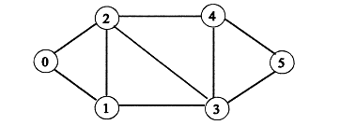
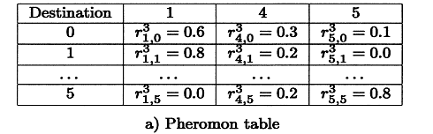
Fig.2 Twin routing Table
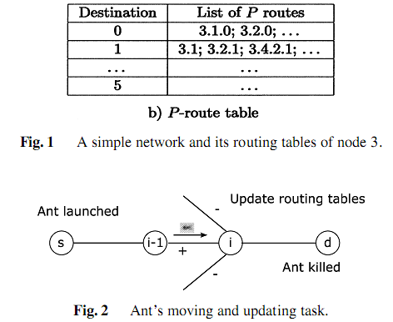
8. Pheromone Table Updating
Whenever an ant visits a node, it updates the pheromone table element with the information gathered during its trip. Suppose an ant moves from source s to destination d following the path (s,... i-1, i,... d). When the ant arrives at node i, it updates the entry corresponding to the nodes as follows: the probability of neighbor i-1 is increased while the probabilities of other neighbors are decreased. If an ant visits node i at time t, so the next values for routing entry in next time t + 1 are determined as follows:
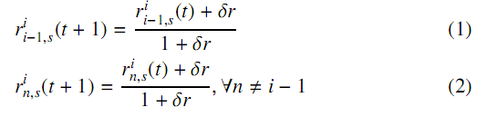
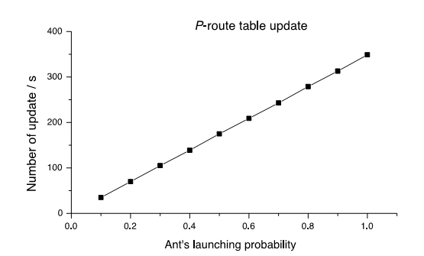
9. P-Route Table Updating
Besides updating the pheromone table, ant also updates the P-route table. As mentioned above, each route is associated with a goodness value that is calculated by the following formula:
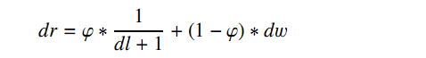
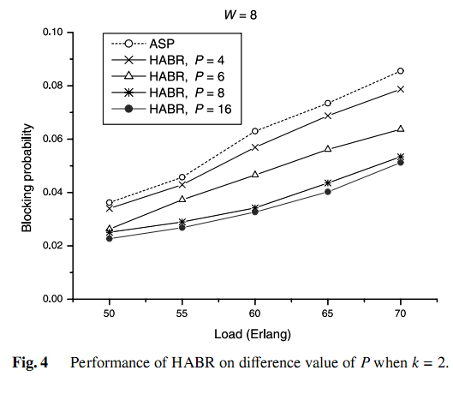
10. Results Analysis:
In this section, we verify the performance of our HABR algorithm based on simulation in a circuit-switched routing module for WDM network in the ns-2 Network Simulator. We adopt the general traﬃc model widely used in performance analysis of data communication networks [17].There are totally T arriving traﬃc sessions; Arriving sessions are distributed randomly over the network. Each trafﬁc session has many connection requests: for each traﬃc session, connection requests arrive according to a Poisson process with an arrival rate λ (call/s). Connection holding time is exponentially distributed with mean µ (s). The total network load is measured by T ∗ λ ∗ µ (Erlang).
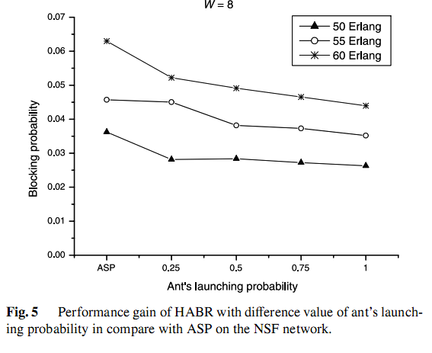
9. Conclusion
In this paper, we implemented a new ant colony optimization algorithm for dynamic RWA in WDM networks based on the combination of ant-based mobile-agents technique and alternate routing method. To enable the new algorithm, we proposed to use a novel twin routing table structure that consists of a P-route table for routing and a pheromone table for mobile agents’ foraging. Our new algorithm is highly adaptive in the sense that it always keeps a suitable number of ants to continuously exploring the network state and proactively updating the P-route routing table. Our simulation results that with a small number of routes in the P-route table and a suitable number of ants, our algorithm can always out perform the promising alternate light-path routing algorithm and the ﬁxed path least congestion routing algorithm in terms of blocking probability while guaranteeing a small setup time in compare with other adaptive routing methods. In the further, we will more evaluate the HABR algorithm in various network situations and its applicability to real optical ﬁber networks.
10. References
[1]. Son-Hong Ngo, Xiaohong Jiang, Susumu Horiguchi, and Minyi Guo: Dynamic Routing and Wavelength Assignment in WDM Networks with Ant-Based Agents. L.T. Yang et al. (Eds.): EUC 2004, LNCS 3207, pp. 829–838, 2004.
[2]. Ramaswami, R., Sivarajan, K.N.: Routing and wavelength assignment in all-optical net-works. IEEE/ACM Transactions on Networking, vol. 3 (1995) 489-500.
[3]. B. Tonderayi Mangara and F. Wilhelm Leuschner,”Survivable Routing for WDM Networks: Challenges faced by the South African Service Providers”, In Proceedings of the Southern African Telecommunications Networks and Applications Conference (SATNAC), 2003.
[4].S. Ramamurthy, Laxman Sahasrabuddhe, and Biswanath Mukherjee, “Survivable WDM Mesh Networks”, IEEE Journal of Lightwave Technology, 2003.
[5]. H. Zang, J. Jue, and B. Mukherjee, “A Review of Routing and Wavelength Assignment Approaches for Wavelength Routed Optical WDM Networks.” Optical Networks Magazine, pp. 47 – 60, January 2000.
[6]. M. Tornatore, G. Maier, and A. Pattavina, “WDM Network Design by ILP Models Based on Flow
Aggregation,” IEEE/ACM Transactions on Networking, Vol 15, No 3, pp 709 – 720, 2007.
[7]. B. Caenegem, W. Parys, F. Turck, and P. Deemeseter, “Dimensioning of Survivable WDM
Networks,” IEEE Journal on Selected Areas of Communication, pp. 1146 – 1157, September 1998.
[8]. D. Banerjee and B. Mukherjee, “Wavelength9routed Optical Networks: Linear formulation, resource
budgeting tradeoffs and a reconfiguration study.” IEEE/ACM Transactions on Networking, pp. 598 –
607, October 2000.
[9]. D. Banerjee and B. Mukherjee, “A practical approach for routing and wavelength assignment in
large wavelength9routed optical networks,” IEEE Journal on Selected Areas of Communication, pp.
903 – 908, June 1996.
[10]. S. Even, A. Itai, and A. Shamir, “On the Complexity of Timetable and Multicommodity Flow Problems,” SIAM Journal of Computing, Vol. 5, pp. 6919703, 1976.
[11]. A. McGregor and B. Shepherd. “Island Hopping and Path Coloring with Applications to WDM Network Design,” SIAM Symposium on Discrete Algorithms, pp. 864 – 873, 2007.
[12]. J. Suurballe, “Disjoint Paths in a Network,” Networks, Vol 4, pp 125 – 145, 1974.
[13]. S. Ramamurthy, “Optical Design of WDM Network Architectures,” Ph.D. Dissertation, University of California, Davis, 1998.
[14]. ] Vinh Trong Lea, Xiaohong Jiangb, Son Hong Ngoa, Susumu Horiguchib and Yasushi Inoguchic, “A novel dynamic survivable routing in WDM optical networks with/without sparse wavelength conversion”, ELSEVIER, Optimal Switching and Networking, 2006.
[15]. Daniel Dao-Jun Kan, Aradhana Narula-Tam and Eytan Modiano, “Lightpath Routing and Capacity Assignment for Survivable IP-over-WDM Networks”, Proceedings of the IEEE 7th International Workshop on Design of Reliable Communication Networks, (DRCN), 2009.
[16] Eytan Modiano and Aradhana Narula-Tam, “Survivable routing of logical topologies in WDM networks”, Proceedings of Twentieth Annual Joint Conference of the IEEE Computer and Communications Societies, IEEE INFOCOM 2001.
[17] Debasis Mandal, Satyajit Nath and Bivas Mitra, “Survivable Routing in WDM Weighted Networks”, Proceedings of the 2nd IEEE International Conference on Communication System Software and Middleware (COMSWARE), 2007.
[18]. ] Kayi Lee and Eytan Modiano, “Cross-Layer Survivability inWDM Networks with Multiple Failures”, In Optical Fiber Communication Conference and Exposition and The National Fiber Optic Engineers Conference, OSA Technical Digest (CD) (Optical Society of America), 2008.
[19]. Timothy Hahn, Shen Wan Montana State University: An Ant Colony Optimization Implementation for Dynamic Routing and Wavelength Assignment in Optical Networks.
[20]. Z. Na and S. Jaijin, “A Distributed Strategy for Dynamic Routing and Wavelength Assignment in
ASON Network,” International Conference on Transparent Optical Networks, pp. 201 – 204, 2005.
[21] S. Ngo, X. Jiang, S. Horiguchi, “Adaptive Routing and Wavelength Assignment Using Ant9Based
Algorithm,” International Conference on Communication Technology, pp. 693 9696, 2003.

